**Oracle Digital Assistant integration with WhatsApp.**

1. Follow the document link :- <https://docs.oracle.com/en/cloud/paas/digital-assistant/use-chatbot/text-only-channels.html#GUID-6E659BE4-F0C9-40E3-8F93-D40ECCD8C8B4>
2. Set up Twilio , and choose the integration with Whatsapp as below

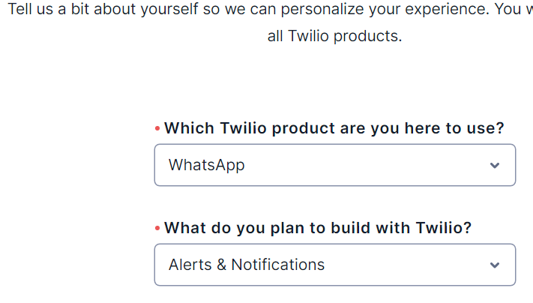

1. You will be lead to the screen, make a note of this number as displayed on the screen.

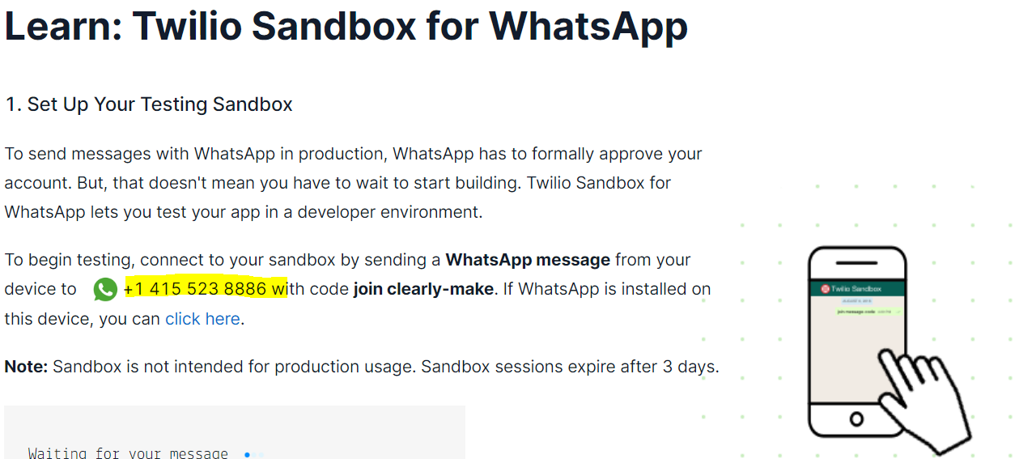

1. Install WhatsApp (if not installed already), and verify if the message has been received.
2. Access ODA.
3. Create channel as below

Specify the details from Twilio as below



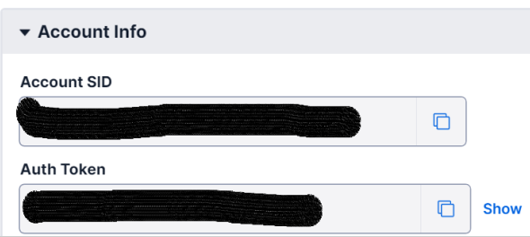

Input these details in ODA while creating channel

1. Choose the routing skill for channel

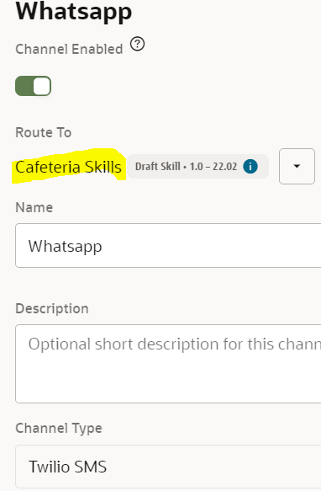

1. Specify the Account SID, Auth Token and phone number(Specify with whatsapp:<phone number>) from Twilio

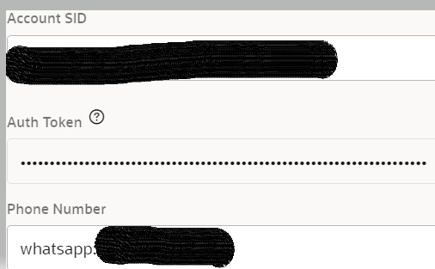

1. Integrating with ODA , need to specify the Inbound URL as below:-

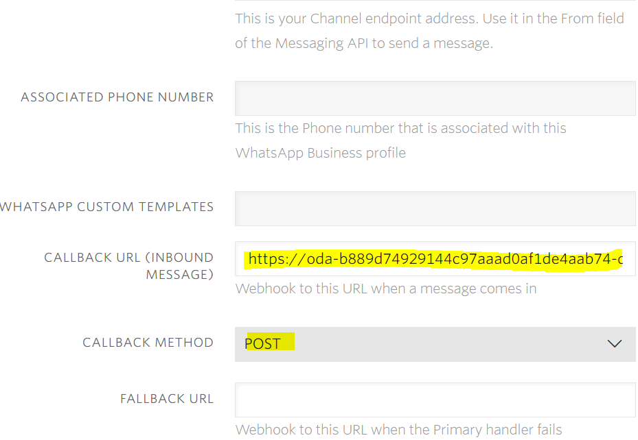

1. Testing the ODA in WhatsApp. Start sending the utterances in WhatsApp, ODA will be responding to it. If not re-check the CALLBACK URL (if not done properly , ODA won’t respond).

